EXPERIMENT 2
NAME:GRACE JEYARANI P ROLLNO:240701158
Design a UI where users recall visual elements (e.g., icons or text chunks). Evaluate the effect of chunking on user memory.
🔹 Problem Statement (same structure as sample)
Users often find it difficult to remember multiple visual elements when they are presented at once. Remembering each item individually increases cognitive load and reduces accuracy.
🔹 Objective (mapped to your project)
To study how chunking helps users remember visual sequences within a 5-second time limit and to evaluate their recall accuracy through a memory-based game.
🔹 Concept Used: Chunking
Chunking is a cognitive technique where information is grouped into meaningful units, making it easier for the brain to store and recall information.
In this project, chunking is applied by grouping similar icons and visual patterns instead of requiring users to remember each icon individually.
🔹 Project Flow (Frame-wise Explanation)
🟤 Frame 1: Introduction / Instruction Screen
Purpose:
To prepare the user for the memory task.
Design Explanation:
Instructions are broken into small steps
Each step explains one action (observe → remember → recall)
This reduces confusion and cognitive overload
Chunking Applied:
Information is chunked into short, clear instruction blocks instead of long text.
🟡 Frame 2: Chunking & Observation Screen (5s Timer)
Purpose:
This screen is used for memory encoding.
Design Elements:
5-second countdown timer displayed at the top
A sequence of icons shown in a structured layout
Icons are visually grouped by:
Similar shapes
Similar colors
Repetition patterns
Chunking Applied:
Users naturally group similar icons into chunks (for example: same icons or patterns), rather than memorizing each icon separately.
Time Constraint:
The countdown timer limits observation time, encouraging users to apply chunking strategies quickly.
🔵 Frame 3: Recall Screen (Memory Test)
Purpose:
To test the user’s memory and evaluate chunking effectiveness.
Design Elements:
A set of icons is displayed
Includes:
Icons from the previous screen
Distractor icons not shown earlier
Users must identify the correct icons based on memory
Chunking Role:
Users rely on previously formed mental chunks to recognize correct icons and reject incorrect ones.
🟢 Frame 4: Result / Feedback Screen
Purpose:
To provide immediate feedback on performance.
Design Elements:
Score display
Correct / incorrect indication
Option to retry or continue
Learning Outcome:
Instant feedback helps users understand how chunking improved or affected their memory performance.
🔹 Connection Between Screens (Very Important – matches sample style)
The task is divided into sequential chunks:
Instruction → Observation → Recall → Feedback
These screens are connected through:
User actions (Start / Submit)
Time-based transition (5-second timer)
This structured flow reduces cognitive load and ensures a smooth user experience.
🔹 Innovation / UX Value
Combines chunking with time pressure
Improves short-term memory recall
Makes cognitive learning interactive through gamification
✅ Final Conclusion
This project demonstrates how chunking, when combined with visual grouping and time constraints, significantly improves memory recall. The game-based interface makes the learning process engaging while effectively evaluating cognitive performance.

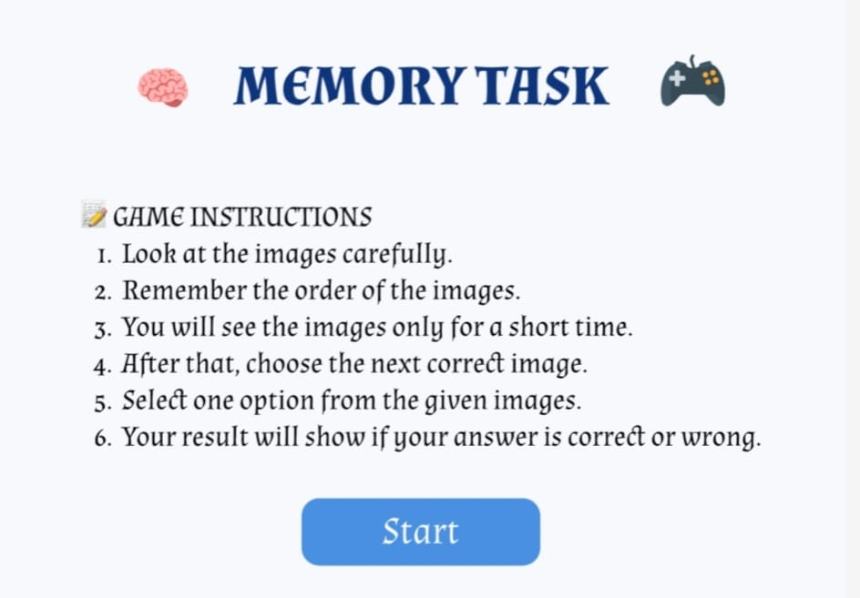

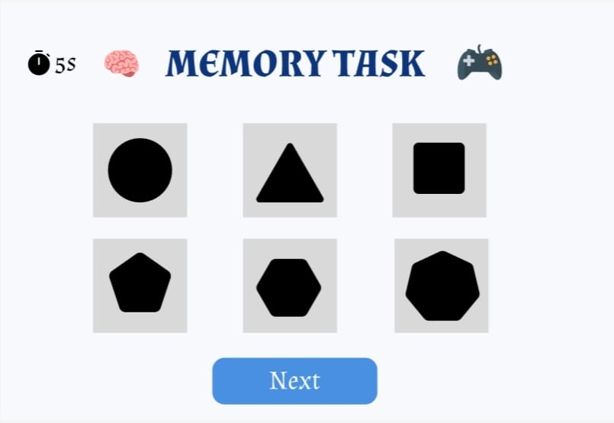
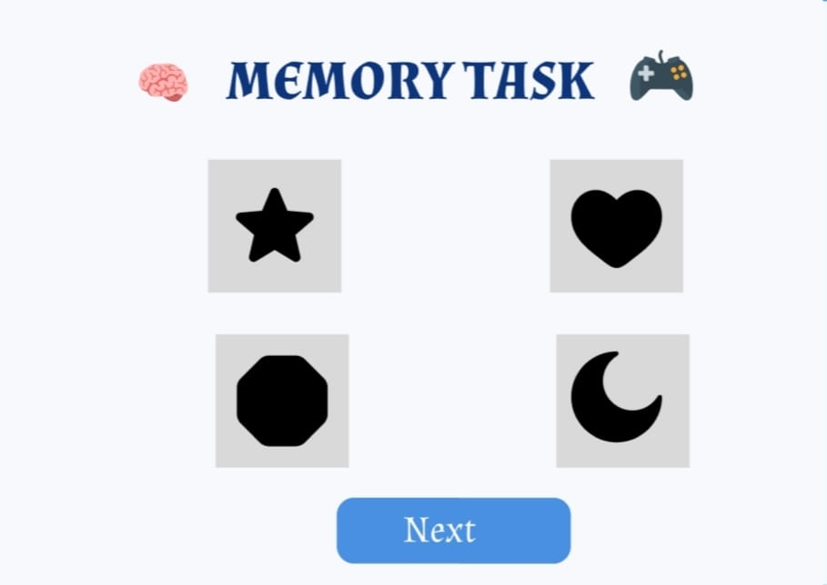
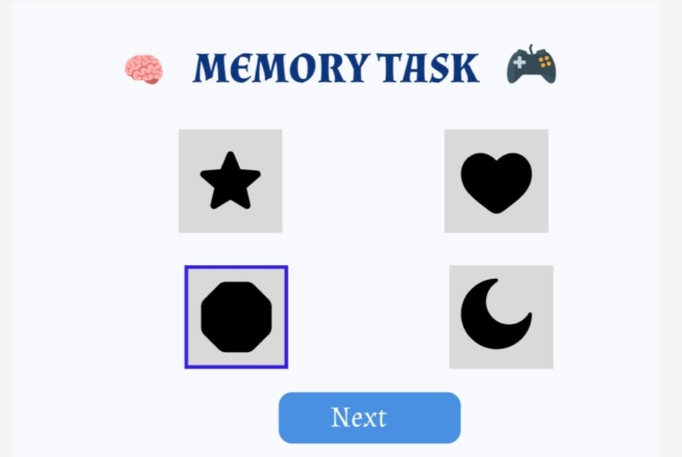

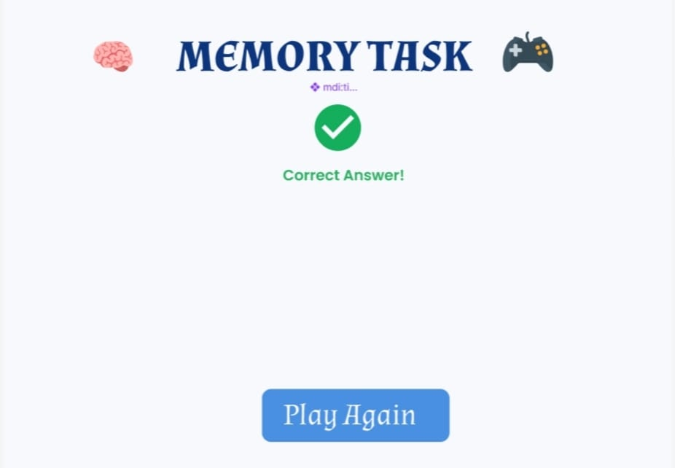
PROTOTYPE:
https://www.figma.com/design/32LvOfMmi5nA6FfSsOmyvw/UID-2?node-id=3-4&t=sVTsf30ebbaKIfax-1

